Key result of pilot study
The Centre on Behavioral Health at the University of Hong Kong had conducted a one year (2012-2013) clinical pilot study to investigate the effectiveness of Hypnotherapy for IBS. The study had recruited 15 subjects with IBS.

Background of 15 subjects
Age Mean（SD） | 38.29(16.15)
Gender  Male  Female | 7 (46%)  8 (54%)
Educational Background  Completed secondary or below  Completed tertiary or above | 3 (20%)  - (80%)

(1) IBS symptom severity score (IBS – SSS Score)
- The severity of symptoms was measured validated, standardized scales. The score dramatically dropped from 26.4 at pre-treatment to 14.3 at post-treatment. (Score “0”represents no symptom, and the total score “50”indicates the recurrence of symptoms). The reduction rate was approximately 50%.
- The score further reduced to 8.08 after three months of the completion of the hypnotherapy group. It indicated that the improvement was persistent over time.
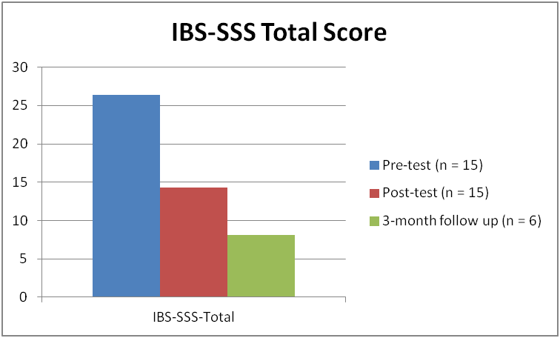
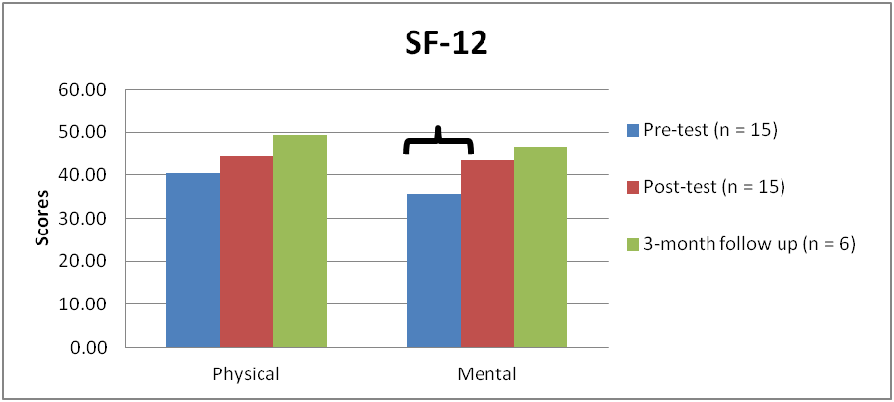
(2) SF-12 : Mental Health
3. There was a significant increase
in mental component score after the intervention, i.e. from 35.73 at pretreatment to 43.75 at post-treatment, t(14)=-2.69, p=.02.

